Blood-Donor-Management-System

Blood Donor Management System using Singly Linked List in C++

1. Problem Statement
Develop a menu-driven Blood Donor Management System using C++ and a Singly Linked List. The system should store and manage blood donor information, including donor ID, name, age, gender, blood group, contact number, and city.
The program should allow users to add, display, search, update, and delete donor records. It should also provide a feature to search for donors by blood group.

2. Objectives
- To understand the implementation of a Singly Linked List in C++.
- To perform insertion, deletion, searching, and traversal operations.
- To maintain donor information dynamically using linked-list nodes.
- To search for donors based on donor ID or blood group.
- To develop a simple menu-driven record management application.

3. Data Structure Used
Singly Linked List
Each node represents one blood donor and contains the donor's information and a pointer to the next node.
Node Structure
Each donor node contains:
- Donor ID
- Name
- Age
- Gender
- Blood group
- Contact number
- City
- Pointer to the next donor node
Linked List Representation
HEAD
|
v
+--------------------------+ +----------------------------+
| Donor 1 | ---> | Donor 2 | --->
| ID, Name, Age | | ID, Name, Age |
| Blood Group, City | | Blood Group, City |
+--------------------------+ +----------------------------+
|
v
NULL
4. Introduction
A Blood Donor Management System is a record management application used to maintain information about blood donors. In this project, a singly linked list is used to store donor records dynamically. Each node contains donor information and a pointer to the next node. Unlike an array, a linked list does not require a fixed size in advance. New donor records can be added by dynamically creating nodes, and existing records can be deleted by modifying pointers.
The application provides a menu that allows users to perform various operations, including adding, displaying, searching, updating, and deleting donor records. This project helps demonstrate important DSA concepts such as linked lists, pointers, traversal, insertion, deletion, searching, and dynamic memory allocation.
5. Algorithm
1. Start the program.
2. Create a Blood Donor Management System object.
3. Display the menu.
4. Accept the user's choice.
5. Perform the selected operation:

- Add donor
- Display all donors
- Search donor
- Update donor
- Delete donor
- Search by blood group
- Exit
6. Repeat the menu until the user selects Exit.
7. Stop the program.

Algorithm for Adding a Donor
1. Create a new node dynamically.
2. Accept the donor's details.
3. Set the new node's next pointer to NULL.
4. If the list is empty, make the new node the head.
5. Otherwise, traverse to the last node.
6. Link the last node to the new node.
7. Display a success message.

Algorithm for Searching a Donor
1. Accept the donor ID.
2. Start traversal from the head node.
3. Compare each node's donor ID with the entered ID.
4. If a match is found, display the donor details.
5. Otherwise, continue until NULL.
6. If no match is found, display a not-found message.

Algorithm for Deleting a Donor
1. Accept the donor ID to delete.
2. Traverse the list while maintaining current and previous pointers.
3. If the donor is not found, display a message.
4. If the first node matches, update the head pointer.
5. Otherwise, connect the previous node to the next node.
6. Delete the selected node.
7. Display a success message.
7. Flowchart
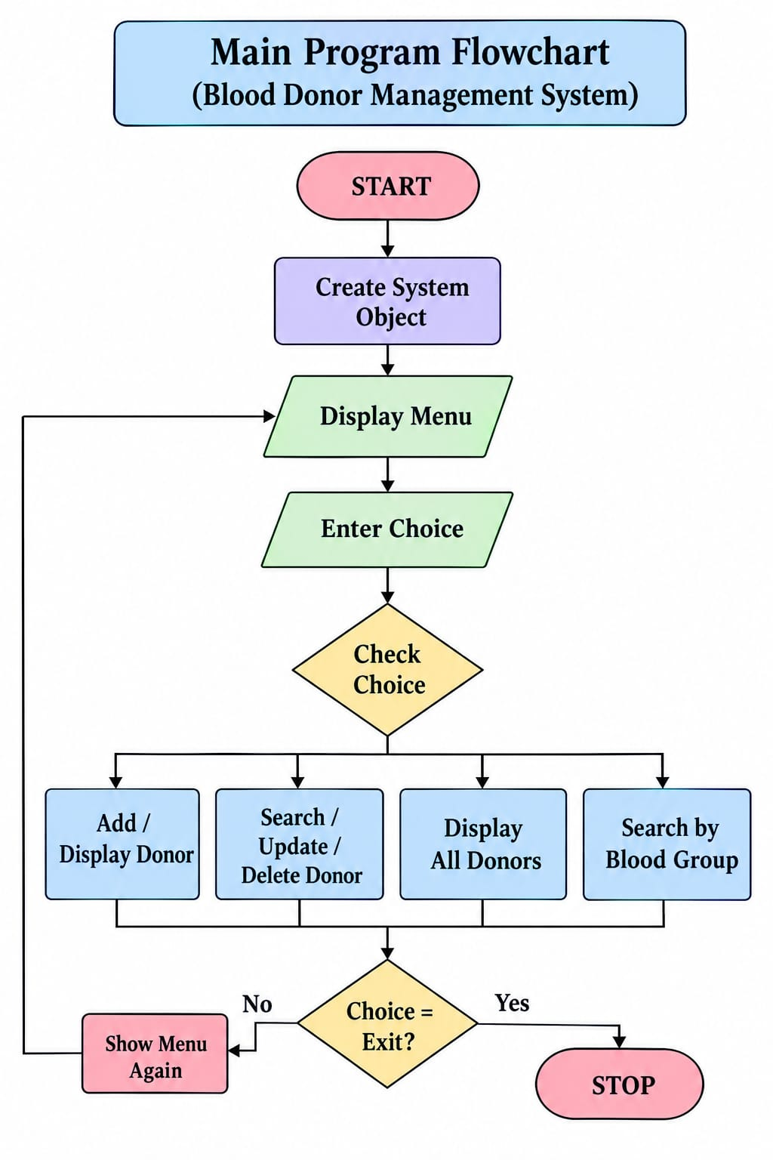
7. Advantages
- Records can be added dynamically.
- The list does not require a fixed array size.
- Insertion and deletion can be performed by changing pointers.
- Donors can be searched by ID or blood group.
- It demonstrates fundamental linked-list operations.
8. Limitations
- Records are stored in memory and are not saved permanently after the program ends.
- Searching requires sequential traversal.
- The program does not verify whether a donor is medically eligible to donate blood.
- It is an educational project and is not a real blood donation or emergency matching service.

9. Conclusion
The Blood Donor Management System demonstrates how a Singly Linked List can be used to store and manage donor records dynamically. It implements insertion, traversal, searching, updating, and deletion in a menu-driven C++ application. This project helps develop an understanding of linked-list operations and dynamic memory allocation.

